Patricia Ladis, PT CBBA
Author of Wise Woman’s Guide to Your Healthiest Pregnancy & Birth

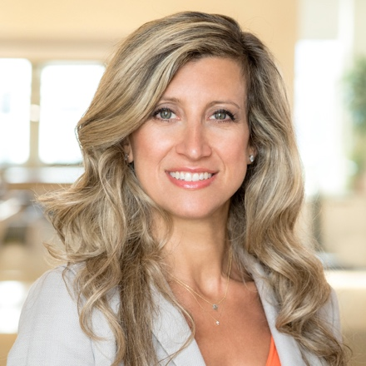
Patricia Ladis, PT, CBBA is a licensed physical therapist and author of Wise Woman’s Guide to Your Healthiest Pregnancy & Birth. Founder of WiseBody Physical Therapy, Patricia previously co-founded the KIMA Center for Physiotherapy & Wellness, one of New York City’s most highly regarded PT and wellness centers. She is also co-founder of The First 1000 Days of Wellness, a global educational platform for practitioners, spas and consumers to promote perinatal wellness and prevent non-communicable diseases in future generations.

A former professional dancer herself, Patricia has been helping pregnant dancers and athletes get back on stage or sport after pregnancy since 1999. She has worked with the Rockettes, various Broadway shows including Fosse, Lion King and Movin’ Out, the American Ballet Theatre and Paul Taylor Dance Company and currently consults with the USTA and WTA. Patricia works with tennis professionals at the U.S. Open and throughout the year, including various players ranked in the top 10 such as Serena and Venus Williams and Mike Bryan.

Always an advocate for women’s health, Patricia is building a new protocol for women returning to sport after pregnancy (WTA, IOC) and has designed the exercise program for the first-ever postpartum exercise study coming out in 2021 with the Hospital for Special Surgery and the Weill Cornell Medical Center. As an active delegate of the Global Wellness Summit and chair of the First 1000 Days Initiative for the Global Wellness Institute, Ladis has support from wellness centers around the world, including Six Senses, Canyon Ranch, Rancho La Puerta and Borgo Egnazia.

She has appeared in articles in Forbes, Vogue, Men’s Health, Thrive Global and Ladies’ Home Journal. TV appearances include NBC and CBS and she regularly appears on Sirius XM’s Doctor Radio.

Patricia’s mission is to guide patients toward a pain free existence as they seek a lifestyle of optimal health and physical wellbeing. She believes in the intimate connection of mind and body and a holistic and collaborative approach to symptoms, health and prevention.

A former professional dancer, Patricia’s background in dance provides her with a unique knowledge of the body and movement. She is passionate about prevention and her treatment caters specifically to each patient’s needs. Her specialized skills, intuitive nature, commitment to higher education and positive energy help her patients avoid surgery and return to prior or higher levels of function and activity.

As a mother of three, Patricia also understands the demands of everyday life and aims to help her patients achieve a balance in their body. She has had all 3 births (natural vaginal birth without medication, C-section and VBAC). She connects with her perinatal patients to help them have a pain free pregnancy and embrace this time in their life with confidence and happiness.

For more information or to book an appointment with WiseBody Physical Therapy, please visit PatriciaLadis.com.

Click here to order Wise Woman’s Guide to Your Healthiest Pregnancy & Birth.

